AIM

To develop and deploy a simple Payroll Processing System as a Software-as-a-Service (SaaS) application using Microsoft Azure, with fields like Employee Name, Experience in Present Organization, Overall Experience, Basic Pay, HRA, DA, TA, Gross Pay, and Net Pay.

PROCEDURE

1. Login to Azure Portal
   * Go to https://portal.azure.com and sign in with your Microsoft Azure credentials.
2. Create a Web App (SaaS Deployment)
   * From the Azure dashboard, click Create a Resource → Web App.
   * Provide details:
     + Subscription: Your Azure subscription
     + Resource Group: Create a new one (e.g., PayrollSystemRG)
     + Name: payrollprocessingapp
     + Runtime Stack: Select Python, Node.js, or PHP (any supported backend).
     + Region: Select the nearest region.
   * Click Review + Create and deploy the Web App.
3. Develop Payroll Application
   * Build a simple web-based payroll form with fields:
     + Employee Name
     + Experience in Present Org (years)
     + Overall Experience (years)
     + Basic Pay, HRA, DA, TA
   * Add backend logic to calculate:
     + Gross Pay = Basic Pay + HRA + DA + TA
     + Net Pay = Gross Pay – Deductions (if any)

(You can create a simple HTML + JavaScript app or use Python Flask and deploy it on Azure Web App service.)

1. Deploy the Application to Azure
   * Push your code to Azure using VS Code, Azure CLI, or GitHub Actions.
   * Test the application using the Azure-provided URL (e.g., https://payrollprocessingapp.azurewebsites.net).
2. Access as SaaS
   * Share the web app URL with users so they can access and use the payroll system through their browser without local installation.

OUTPUT:

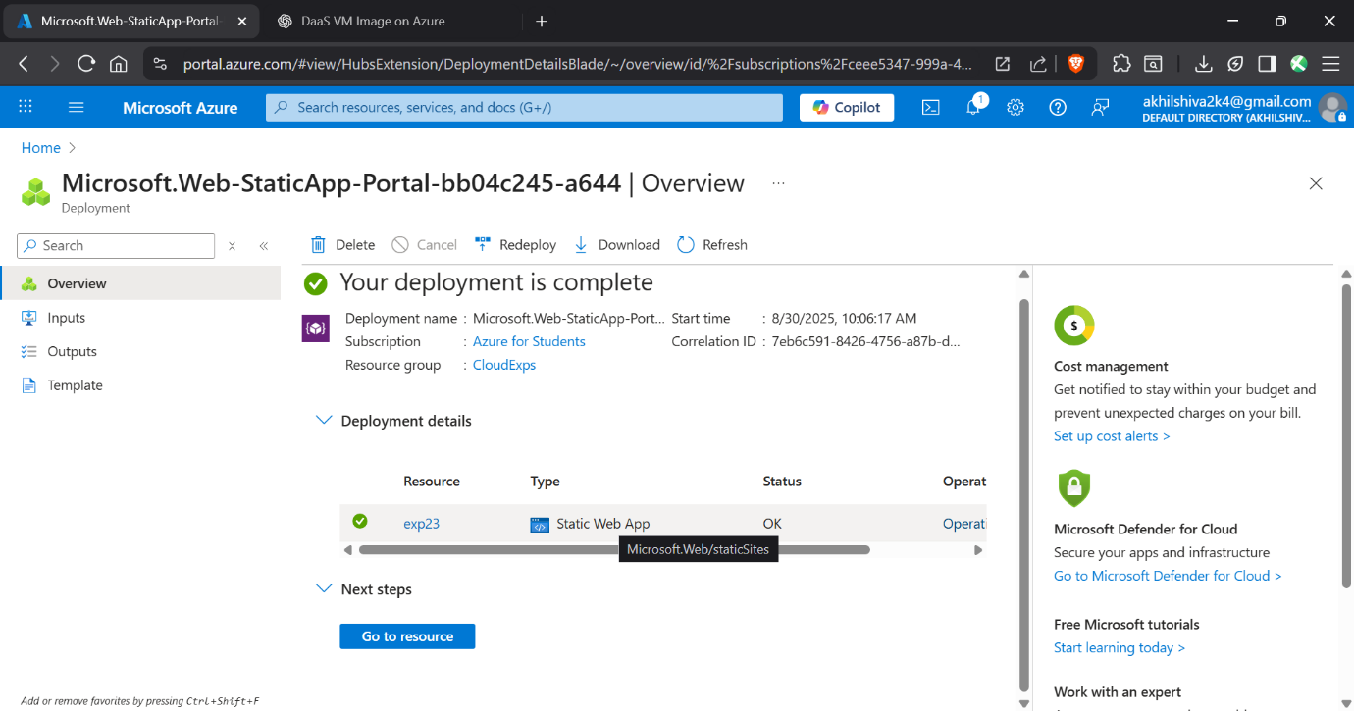

RESULT

The Payroll Processing System was successfully deployed as a SaaS application on Microsoft Azure.

* Users were able to input employee details and salary components.
* The system automatically calculated Gross Pay and Net Pay and displayed them on the web page.
* The application was accessible from any device via the Azure-provided web link, demonstrating the SaaS model.